**Aryaman Mishra**

**19BCE1027**

**LAB 6**

1. **Simple hello world mpi**

#include<stdio.h>

#include <mpi.h>

int main()

{

printf("hello world\n");

return 0;

}

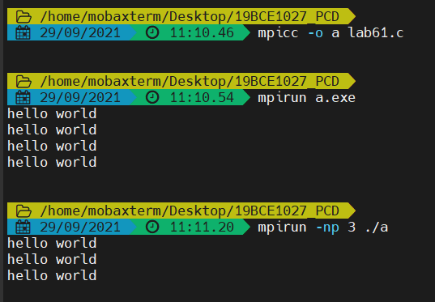

1. **Getting started with MPI program**

#include <mpi.h>

#include <stdio.h>

int main(int argc, char** argv) {

// Initialize the MPI environment

MPI_Init(NULL, NULL);

// Get the number of processes

int world_size;

MPI_Comm_size(MPI_COMM_WORLD, &world_size);

// Get the rank of the process

int world_rank;

MPI_Comm_rank(MPI_COMM_WORLD, &world_rank);

// Get the name of the processor

char processor_name[MPI_MAX_PROCESSOR_NAME];

int name_len;

MPI_Get_processor_name(processor_name, &name_len);

// Print off a hello world message

printf("Hello world from processor %s, rank %d out of %d processors\n",

processor_name, world_rank, world_size);

// Finalize the MPI environment.

MPI_Finalize();

return 0;

}

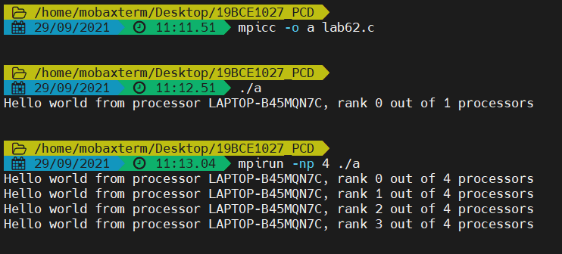

1. **Write a MPI program that will print your name along with all processes with odd ranks.**

#include <mpi.h>

#include <stdio.h>

int main(int argc, char** argv) {

// Initialize the MPI environment

MPI_Init(NULL, NULL);

// Get the number of processes

int world_size;

MPI_Comm_size(MPI_COMM_WORLD, &world_size);

// Get the rank of the process

int world_rank;

MPI_Comm_rank(MPI_COMM_WORLD, &world_rank);

// Get the name of the processor

char processor_name[MPI_MAX_PROCESSOR_NAME];

int name_len;

MPI_Get_processor_name(processor_name, &name_len);

// Print off a hello world message

//printf("Hello world from processor %s, rank %d out of %d processors\n",

//processor_name, world_rank, world_size);

if(world_rank%2==0)

{

printf("Hello world from processor %s, rank %d out of %d processors\n",processor_name, world_rank, world_size);

}

else

{

printf("Aryaman Mishra 19BCE1027 from processor %s, rank %d out of %d processors\n",processor_name, world_rank, world_size);

}

// Finalize the MPI environment.

MPI_Finalize();

return 0;

}

